LYON, January 20 2017
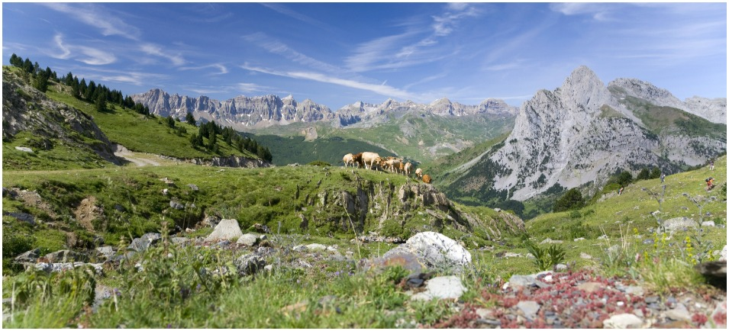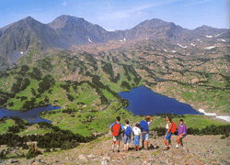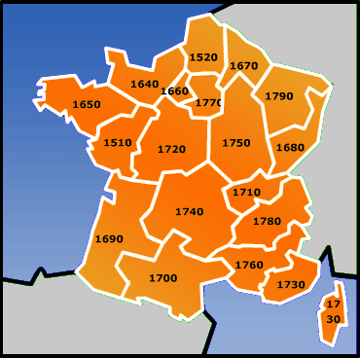

"MOUNTAIN CAMP 2017 "

Dates : Saturday 24th JUNE to Thursday 6th JULY 2017
Host Club : FONT ROMEU CERDAGNE CAPCIR / District 1700

Participants : 15 / 1 BOY or 1 GIRL from your country / 18 - 23 years old at the beginning of the camp (candidates under 18 won’t be accepted)

Aim of the camp : To discover the Cerdagne and Capcir valleys in the Pyrenees through outdoor
activities and sport

Program : hiking, tree climbing, , discovery of Naturlandia in Andorra, the Fontrabiouse cave, a wildlife park in Les Angles, Rotary meetings…A detailed program will be sent later by the Organizer

Language : FRENCH or/and ENGLISH

Accommodation : in a holiday center

Arrival and departure : FORMIGUERES (department 66)

Fees : 500 euros /participant, to be paid before 24th MAY

Insurance : against illness, accident and third party damages ; participants will send the certificate to the Organizer before the arrival in France

Application : by email with all requested signatures to : gisele.pont@crjfr.org

