LYON, February 6 2017
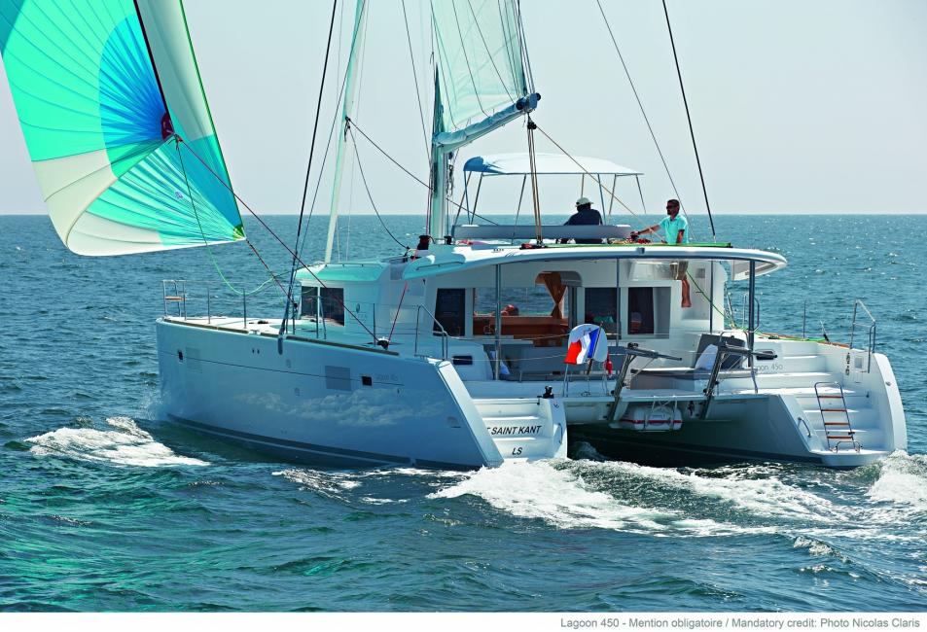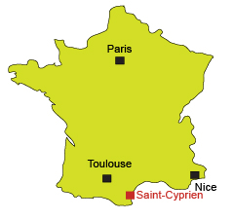

" SAILING AND DISCOVERING THE CATALAN COASTS "

Dates : Saturday 24th JUNE to Monday 3rd JULY 2017 Participants should arrive on 24th June

Host Clubs : PERPIGNAN / District 1700

Participants : 8 BOYS and GIRLS from 8 countries / 18 - 24 years old at the beginning of the camp
(candidates under 18 will not be accepted)

Program : Learning how to drive a catamaran (“Lagoon 450” see the picture above) enjoying and discovering the local cultural, economic and environmental resources of Saint Cyprien, Collioure (France) and Blanes, Rosas (Spain) . A detailed program will be sent later by the Organizer

Languages : FRENCH or/and ENGLISH

Hosting : on board the catamaran and 3 nights in mobile homes

Arrival and departure : SAINT CYPRIEN (66750)

Fees : 400 euros /participant, to be paid before 24th MAY

Insurance : against illness, accident and third party damages ; participants will send the certificate to the Organizer before the arrival in France

Application : by email with signatures to : gisele.pont@crjfr.org

