LYON, March 3 2017
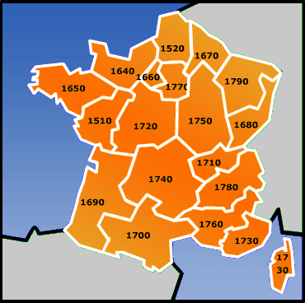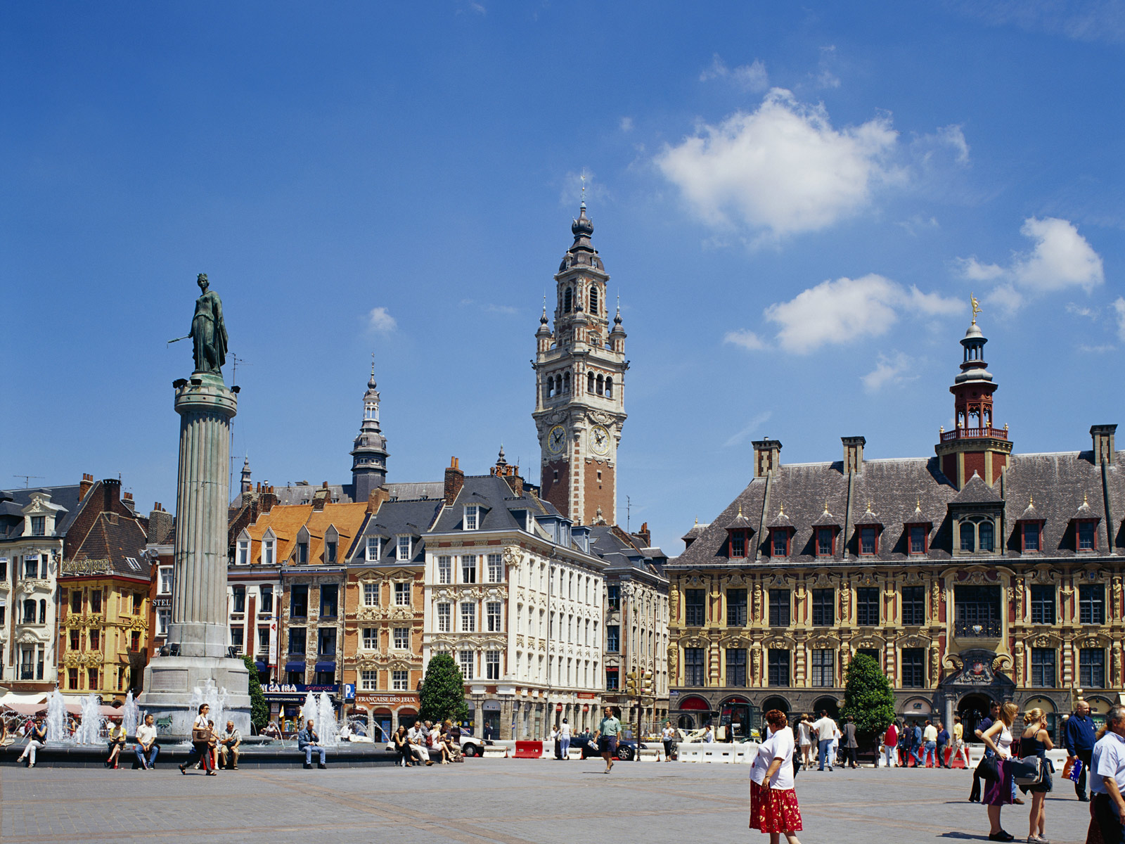

" INDUSTRIAL AND CULTURAL HERITAGE IN THE NORTH OF FRANCE/ARDENNES AREA"

Dates : Saturday 1st to Saturday 15th JULY 2017
Host Club : TEMPLEUVE EN PEVELE and CHARLEVILLE Rotary Clubs - District 1670

Participants : 8 / 1 BOY or 1 GIRL from your country / 18 - 19 years old at the beginning of the camp (candidates under 18 won’t be accepted)

Program : discovery of LILLE, a crystal factory, an historic mining centre, a famous champagne house, a trip to Paris … while sharing friendship …A detailed program will be sent later by the Organizer

Language : ENGLISH

Accommodation with families and in a hotel. A one week further family hospitality could be proposed to participants coming from non-European countries

Arrival and departure : PARIS Charles De Gaulle airport

Fees : 300 euros /participant, to be paid before 1st JUNE

Insurance : against illness, accident and third party damages ; participants will send the certificate to the Organizer before the arrival in France

Application : by email with all requested signatures to : gisele.pont@crjfr.org

