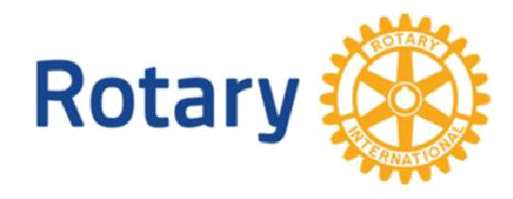
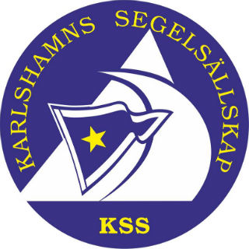

KARLSHAMN ROTARY CLUB | KARLSHAMN-MÖRRUM ROTARY CLUB | KARLSHAMN SAILING SOCIETY
District 2400, Sweden | District 2400, Sweden | Member of World Sailing, Sweden

INTERNATIONAL YOUTH SAILING CAMP

Karlshamn Rotary Club, Karlshamn-Mörrum Rotary Club, Karlshamn Sailing Society

invites You to

LEARN AND PRACTICE SAILING IN THE SOUTH SWEDISH ARCHIPELAGO

Dates: 29/7 – 9/8 2017

Sponsor The Rotary Clubs of Karlshamn and Karlshamn-Mörrum, the sailing society
Clubs: of Karlshamn and the golf club of Karlshamn.

Participants: Boys and girls, 16-18 years old, from different European countries (max. number of participants is 18). Ability to swim and to ride a bike is a necessity, but not previous experience of sailing.

Camp To learn and practice sailing and to discover the nature and archipelago of
Purpose: southern Sweden and also to learn about our community, industry and social life. Meeting young people from different countries with different cultures, helping to bring peace and understanding to the world!

Program: Training and sailing in small keelboats, in sheltered waters, including one camping night on an island in the archipelago with different other water activities. Practicing golf and other social meetings and events, community visits and participation in Rotary meetings.

Language: English

Accommodation: Rotary families.

Costs: The journey to and from the camp as well as insurance to be paid by the participant. The organizing Rotary clubs sponsor the cost for the whole stay and all activities.

Insurance: The participants must be insured against illness, accident and third party
damages.

Clothing and Normal leisure and travel clothes. No special equipment is needed.
Equipment: Applicants who are accepted will receive a detailed list of clothing
suggestions.

Internet The camp can be followed “live” on the Internet, with daily updates about the
activities via a Facebook group account. A great way for the folks at home to enjoy the camp too!

Arrival: Travel plans should be made for arrival in the afternoon of Saturday July
29th or on Sunday July 30th 2017. Pickup will be arranged upon arrival to
Ronneby airport, which is the nearest airport to Karlshamn (30 km).
Ronneby is served by regular flights from Arlanda or Bromma airports in Stockholm. There is also an hourly direct train connection (about 2,5 hrs) from Copenhagen airport (in Denmark) to Karlshamn, if this airport is selected. Pickup will also be arranged at nearby ferry stations. Suitable ferries land in Karlshamn from Lithuania or in Karlskrona from Poland (Gdynia). Corresponding planning should be made for travelling home, leaving Karlshamn on August 9th, 2017.

Closing Date March 31, 2017.
for Application: After this date we are going to select the participants among applicants.

Application Form Please send, preferably by PDF-file, the Rotary Youth Exchange / Short-Term Exchange Program (STEP) Application - Form with photos. The application form should be available at your national Rotary EEMA Camp Coordinator.

The Form
shall be sent to: Karlshamn Rotary Club Phone: + 46 708 102 865
c/o Lars Åke Lund E-mail: lund@lund-fagrenius.se
Skogsvägen 15
SE 374 37 KARLSHAMN
SWEDEN
